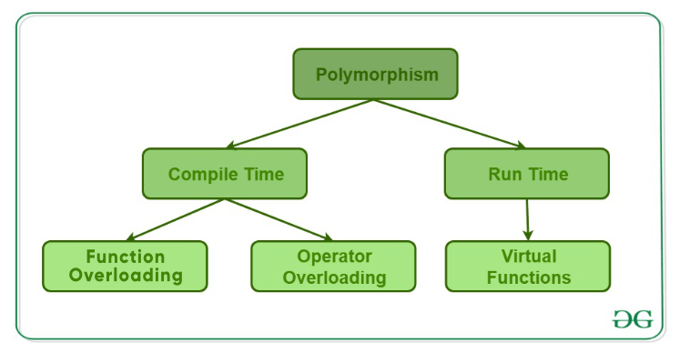



In C, virtual functions 🡪 In JAVA, Dynamic method dispatch

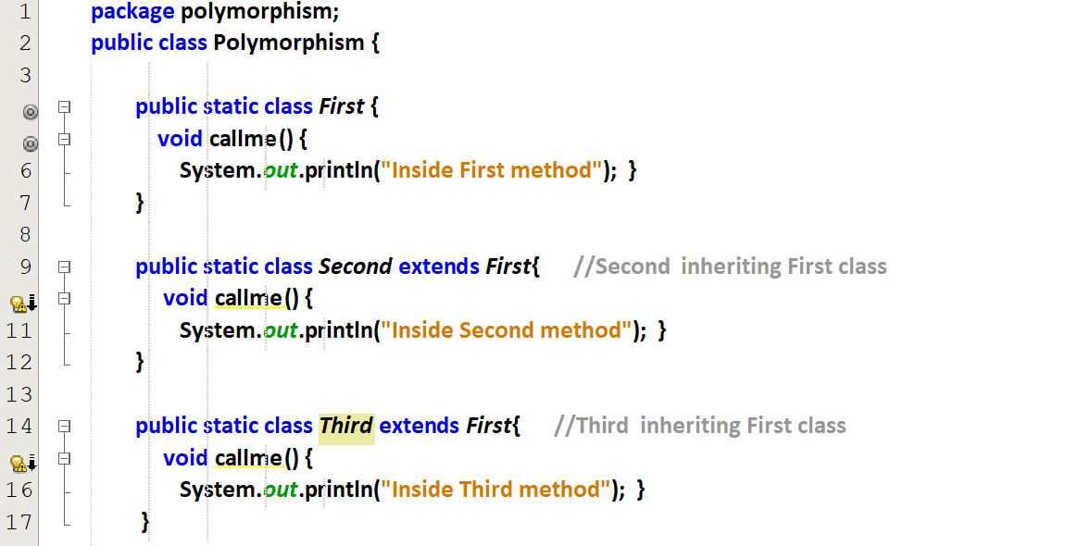  
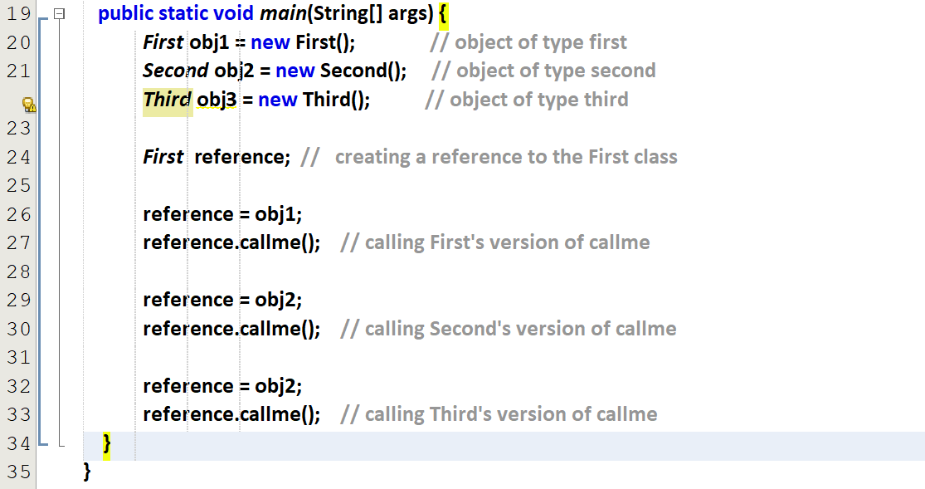

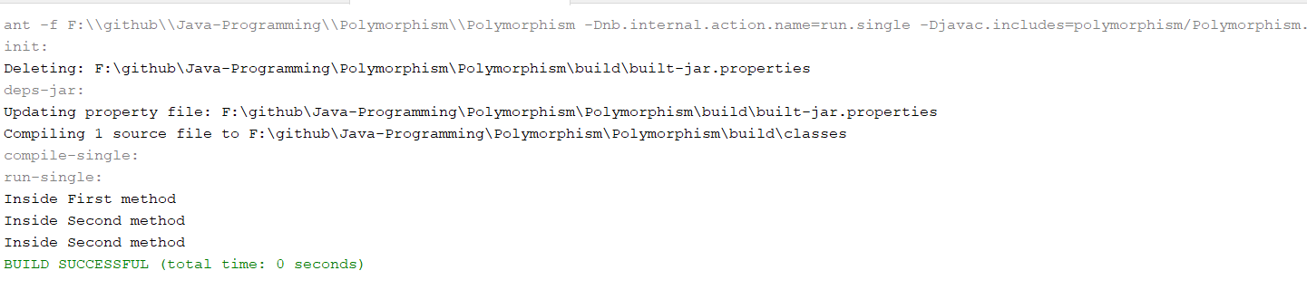

Polymorphism 🡪 taking decision only at the run-time.

Child class method is supressing/over-riding/dominating the parent class method.

B’s call me is over-riding A’s call me.  
C’s call me is over-riding B’s call me and A’s call me.

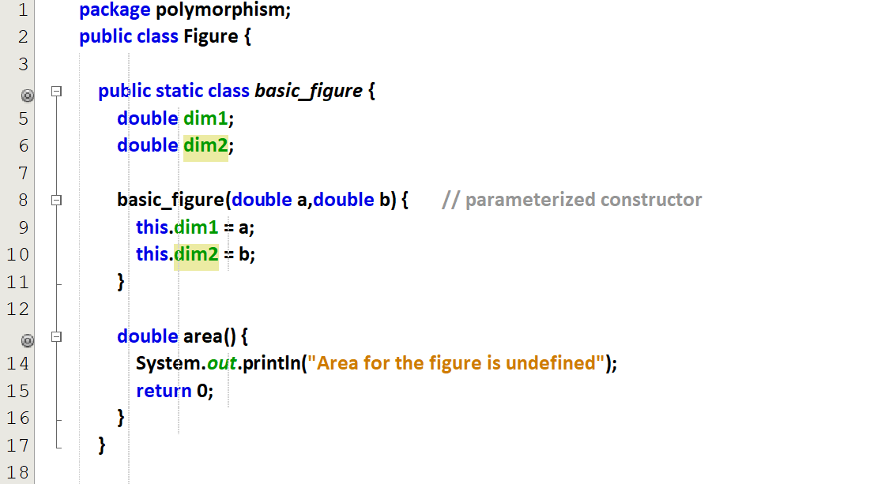  
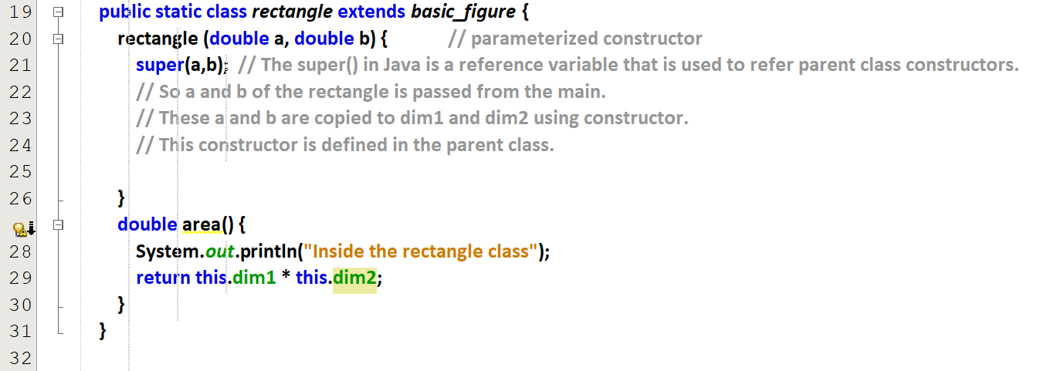  
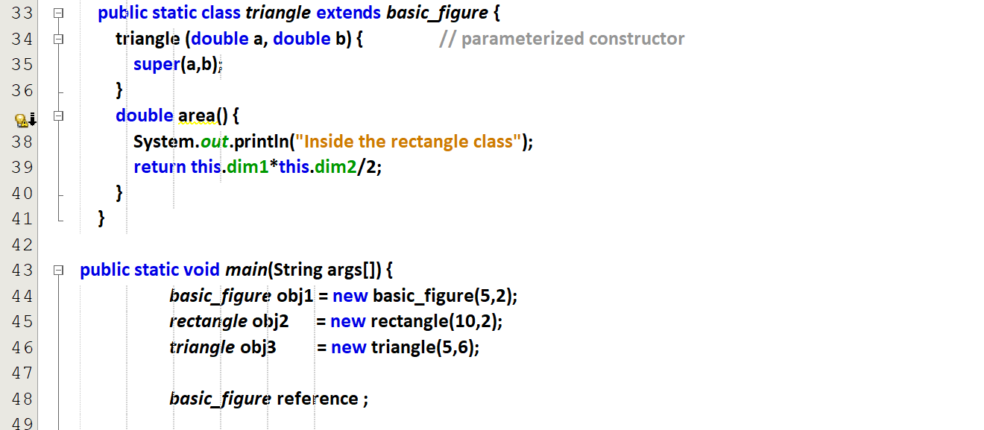

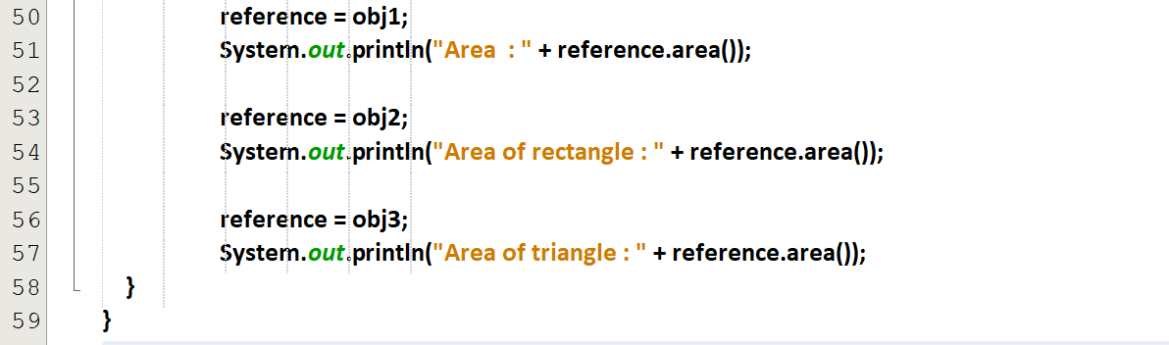

The **super() in Java** is a reference variable that is used to refer parent class constructors.

